Who was a roman citizen?  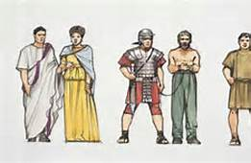 | - 1.  - 2.  - 3.  - 4.  - 5. Latini:  - 6. Peregrini:
Who was not a roman citizen? | - 1.  - 2.
What responsibilities did citizens have? | - 1.  - 2.
What were the rights of Roman citizens?  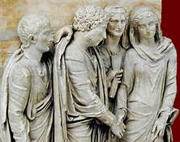 | - 1. Suffragium:  - 2.Commercium:  - 3. Conulaum:
What were the rights of Female Roman citizens? | Could not:  - 1.  - 2.  Could:  - 1.  - 2.  - 3.
The Roman Legal System  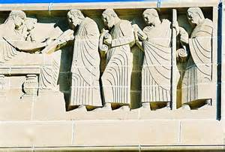 | The Twelve Tables:  Corpus Juris Civilis:
The Roman Political System  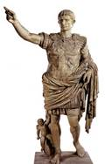 | Emperor:  Dictator:  Patricians:  Senators:  Equestrians:  Plebians:  Slaves:  Freedmen:
The Roman Military  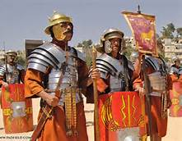 | Who could be in the military?  Who controlled the military?  How did the Roman Military get themselves and their supplies to battles faster than their opponents?
Write down questions you have throughout the lecture in these boxes so you remember them when it is time to ask =)

