Discussion Character Profiles:

Roman Catholic Bishop (Pope)  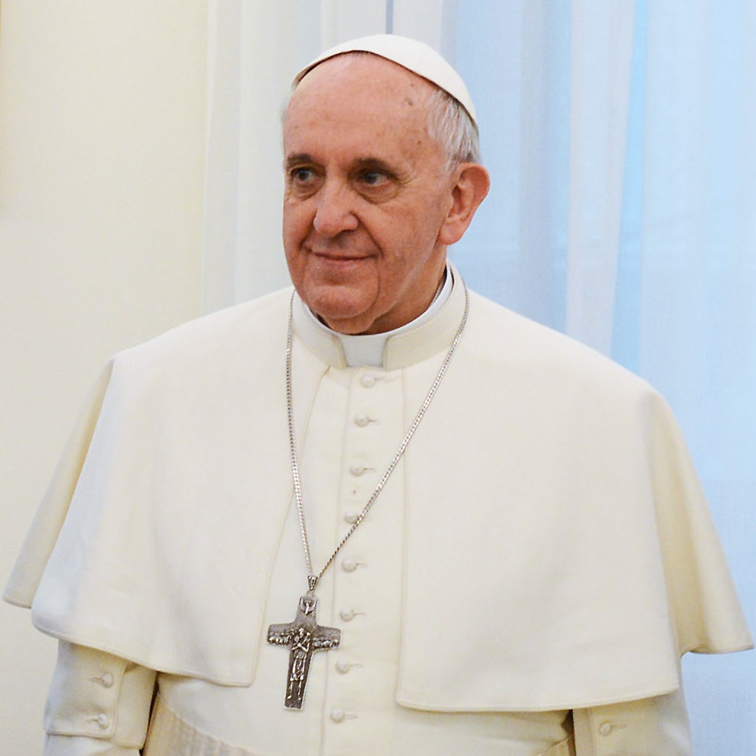 | - Bishop in the western Empire  - Roman Catholics believe that the Pope should be the leader over all Christians (after Peter was the first Bishop in Rome)  - Used to follow “caesaropapism” but now there is no Emperor in the West
Romans in the Western Empire  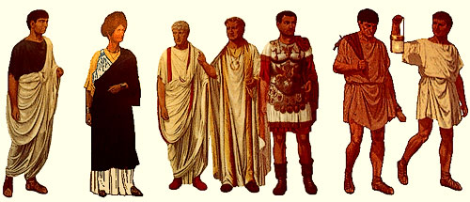 | - Speak Latin  - Under attack  - Emperor moved to greener pastures  - Eastern empire has a different language and cultural influences  - Church survived in Rome  - Need leadership
Emperor in the Byzantine Empire  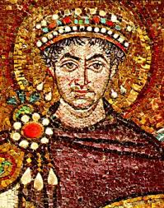 | - Moved the capital  - Made Christianity the official religion of the Empire after moving  - Built a new church to rival St. Peter’s Basilica  - Assumes “Caesaropapism” will be upheld  - Ruling the region with more people and money
Greek Orthodox Bishop  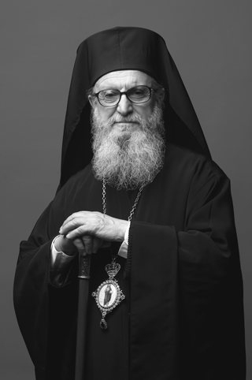 | - Leading all the churches in the new Eastern Empire  - Using a new language in his churches  - Living under the Emperor
Romans in the Eastern (Byzantine) Empire  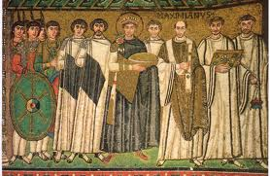 | - Speak Greek  - Protected by Emperor  - Influenced by new cultures  - Following the Greek Orthodox bishop

